**Ideation Phase**

**Empathize & Discover**

|  |  |
| --- | --- |
| Date | 15 JUNE 2025 |
| Team ID | LTVIP2025TMID46308 |
| Project Name | DOCSPOT |
| Maximum Marks | 4 Marks |

**Empathy Map Canvas:**

**An empathy map is a clear, visual tool that helps teams capture insights about a user’s thoughts, feelings, behaviors, and needs. It's designed to foster a deeper understanding of the user by encouraging teams to step into the user's shoes.**

**By focusing on what users say, think, do, and feel, teams can align around a shared understanding and design better, more relevant solutions. Creating an empathy map is a collaborative exercise that shifts the focus from assumptions to real user needs, frustrations, and goals.**

**Example:**

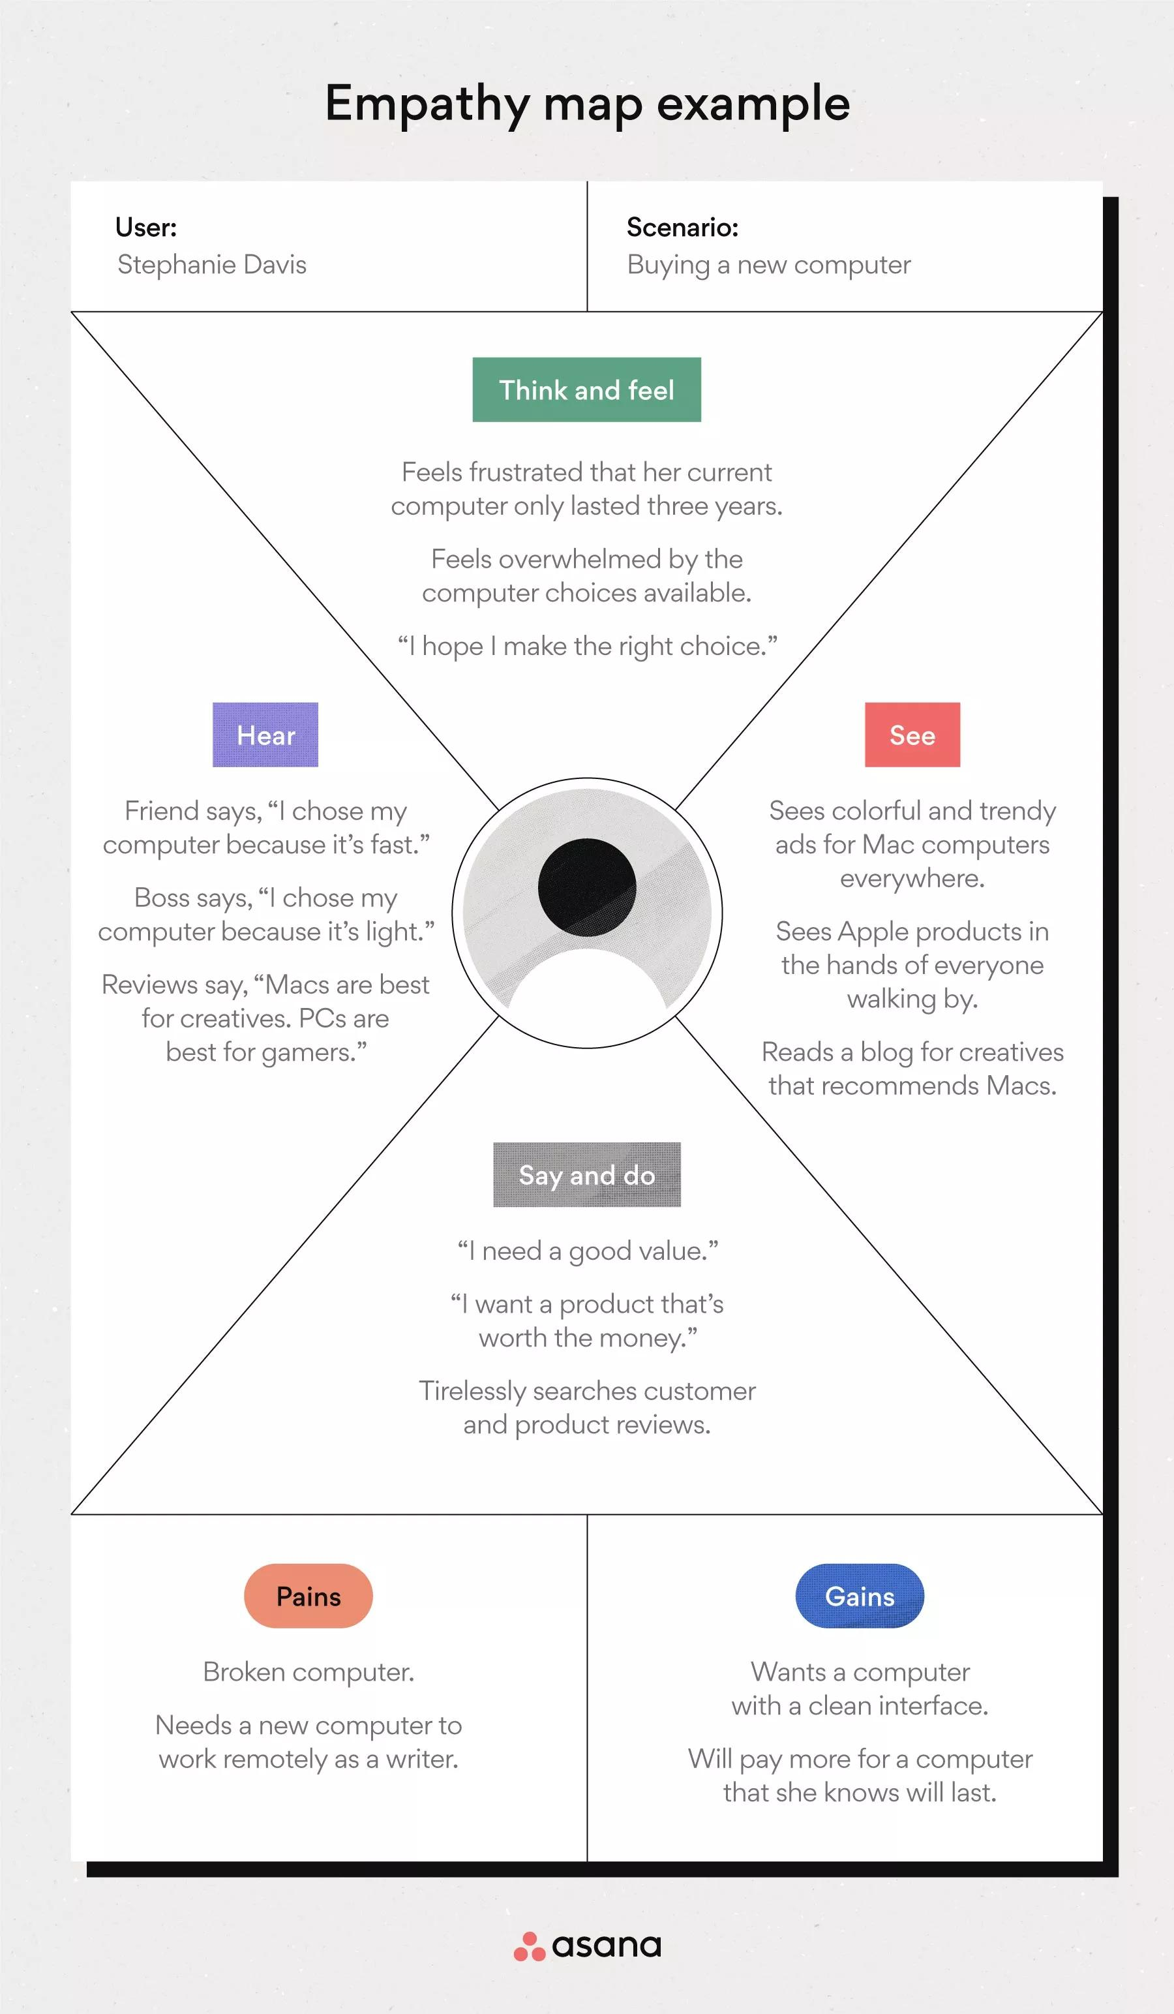

Reference: <https://www.mural.co/templates/empathy-map-canvas>

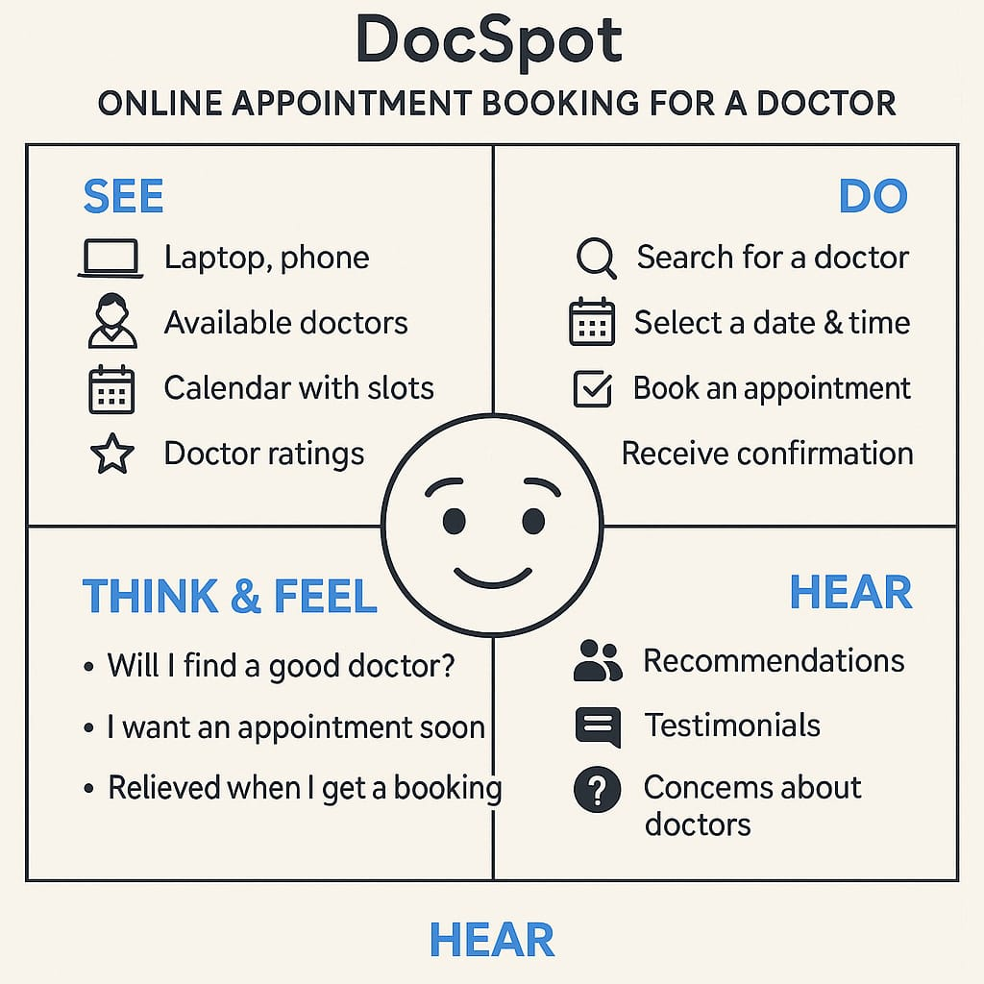**Example: Doc Spot online appointment booking for a doctor**